Friends, Not Foes!

By Naza Ezenyem
Teacher's Guide & Classroom Resource
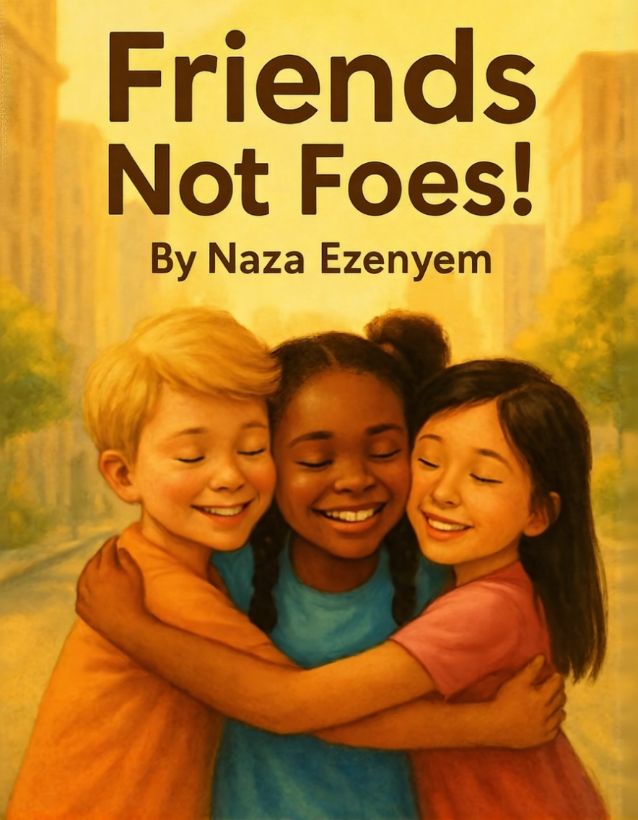

About the Book
Friends, Not Foes! is a heartwarming story written for children aged 4-8 years. The book follows a young boy and his friends as they learn the importance of empathy, kindness, and standing up for one another. About the Author Naza Ezenyem wrote this book when she was just 5 years old, inspired by her own experiences at school.
Now at age 10, she shares stories that help children understand their feelings and treat others with love and respect.

Themes and Learning Outcomes
Empathy: Understanding and sharing feelings.
Friendship: Building strong, positive relationships.
Problem-Solving: Working together to solve conflicts. •
Kindness: Treating others with respect and care.

Discussion Questions
What problem did the characters face in the story?
How did they feel when things went wrong?
What choices could they have made differently?
What does being kind mean to you?

Classroom Activities
Role-play: Act out scenes from the book and explore different solutions.
Friendship Chain: Each student writes a compliment for a classmate on a paper strip to create a chain link
Draw & Tell: Students draw their favorite part of the story and share why. •
Kindness Jar: Add notes of kind deeds done by classmates throughout the week.

